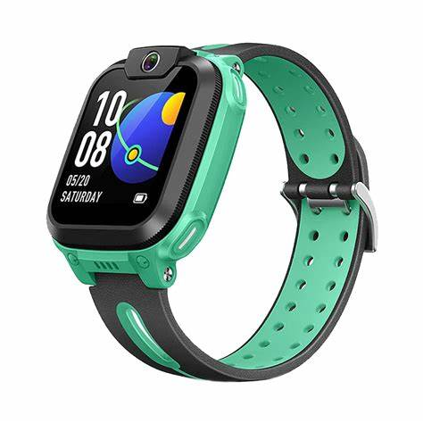**Description:** imoo is a leading brand specializing in smartwatches designed specifically for children, focusing on safety, communication, and learning. imoo smartwatches feature advanced technology, including 4G LTE connectivity, HD video calling, real-time GPS tracking, and class mode to minimize distractions during school hours.

These smartwatches allow parents to stay connected with their children through messaging, voice calls, and video chats. imoo also prioritizes safety with features like geofencing alerts, SOS buttons, and waterproof designs for durability. Some models even include fitness tracking, AI learning assistants, and step counters to encourage an active lifestyle.